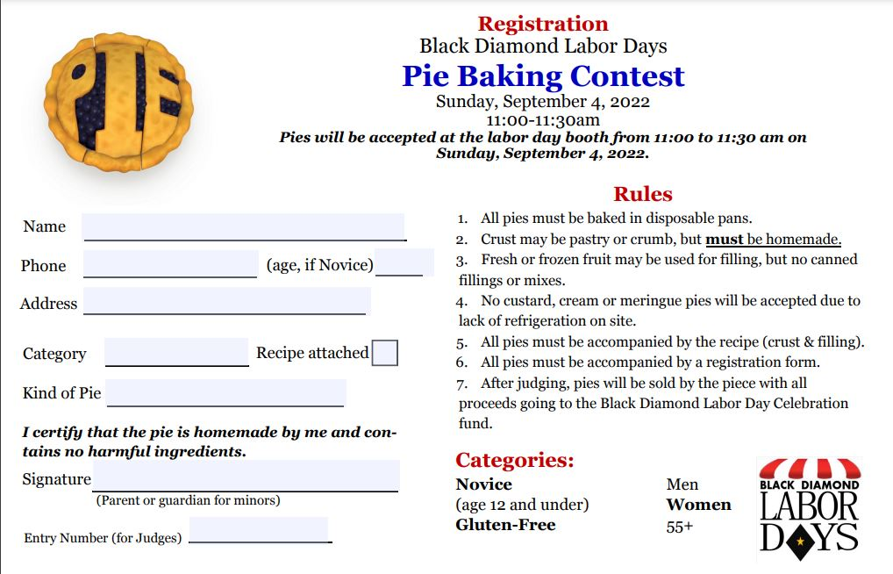
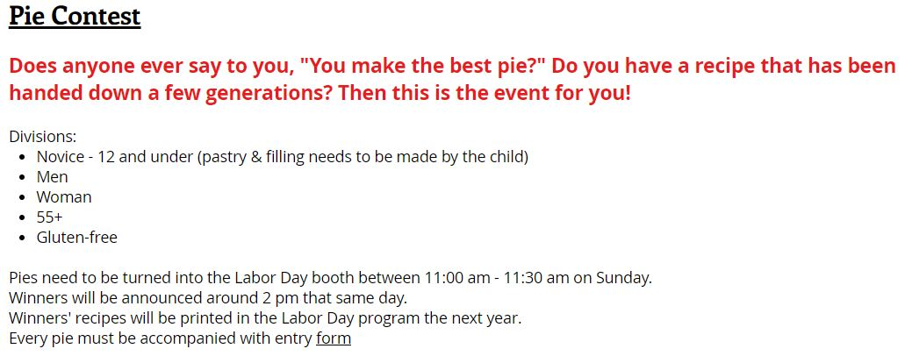

Sunday, August 31, 2025
Sunday, August 31, 2025
https://forms.gle/KQVjWY1x3N41P9rXA
#
1

